SAMUKTALA SIDHU KANHU COLLEGE
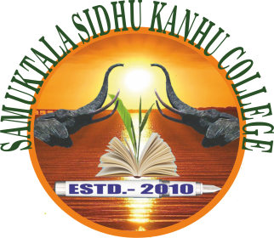
PO: TALESWARGURI= DIST.: ALIPURDUAR
WB: 736206
(Affiliated to University of North Bengal)
Website: samuktalasidhukanhucollege..in
Estd. 2010 E-mail: shamuktala.sk.college@gmail.com
Ref No. Date: 23.12.2021
N O T I C E

(Observation of Students’ week during 1stto 7thJanuary 2022)

All the students of Samuktala Sidhu Kanhu College are hereby informed that from 01.01.2022 to 07.01.2022 College is going to observe “Students week” through various programme .All the students are asked to attend the programme positively. Interested students are asked to participate and submit their name category wise.

Contact Us.
1.Ramendra Nath Bhowmick -9093537924
2. Dr. Amrita Das-7076056525
3. Dr. Md Mizanur Rahaman-8449755694
4.Rajib Kar-9679267587
5. Nasir ansary
6.Dipika Ghosh-7407284661
7.Abdul Wahid Momin-8509096722 Sd/-
Teacher in Charge
Samuktala Sidhu Kanhu College.

PROGRAMME SCHEDULE
Date | Event
01/01/2022 | - Observation of students’ day  - Cricket Tournament  - Clean Campus Initiative
02/01/2022 | - Football/Volleyball Tournament  - Badminton Tournament
03/01/2022 | - Cultural Competition  - RabindraSangeet  - NazrulGeeti  - Folk Songs  - Poster Presentation  Theme: Clean & Healthy Environment  Benefits of Government Social Schemes  Observance of Covid 19 Protocol in University Campus  - Help Desk for awareness campaign on Student Credit Card Scheme
04/01/2022 | - Blood Donation Camp  - Free Health Check-up Camp  - Help Desk for awareness campaign on Swami Vivekananda Merit-cum-Means Scholarship  - Debate Competition : Learning at University - Online Vs. Offline
05/01/2022 | - Covid 19 Vaccination Camp  - Essay Competition: ছাত্রছাত্রীদের সহায়তায় রাজ্য সরকারের ভূমিকা  - Helpdesk for awareness campaign onKanyasree 3, Aikyashree and other State Govt. Scholarship Schemes
06/01/2022 | - Seminar on Digital Education  - Quiz competition  - Helpdesk for awareness campaign on Other Post-Graduate Scholarships and Fellowships for University Students
07/01/2022 | - Prize distribution  - Cultural Programme

